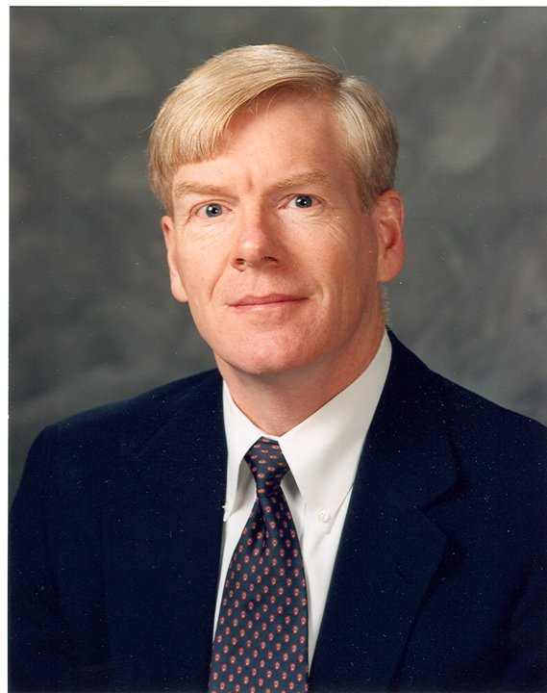

Mark J. Harper, PhD, P.E.

1727 Robinhood Road

Annapolis, MD 21401

410-849-USNA

[753752@gmail.com](mailto:markjharper75@gmail.com)

Dr. Mark J. Harper directed the International Atomic Energy Agency’s nuclear power technology development program for water cooled reactors since 2011, and for 2016 was senior specialist in their nuclear knowledge management section. He coordinated and supervised the IAEA’s projects in accordance with the needs of Member States, served as scientific secretary for international conferences, and interfaced with the Agency’s Nuclear Safety, Nuclear Security, and Nuclear Safeguards departments. He also planned and conducted workshops on reactor technology assessment in countries that are embarking on or expanding their civil nuclear power programs.

Before moving to the IAEA in 2011, Dr. Harper taught in the Mechanical Engineering department at the United States Naval Academy for 25 years, first as a naval officer and then as a civilian professor. His Ph.D. in Nuclear Engineering is from the University of Maryland (1991), and his M.S., also in Nuclear Engineering, is from MIT (1976). A Mechanical Engineering major at the Naval Academy, he graduated in the top 1% of his class. He had 14 years experience in the Navy's nuclear power program as an operational submarine officer and as an instructor at the Navy's nuclear power school. He is a registered professional engineer (P.E.) in the commonwealth of Virginia. Dr. Harper was the inaugural winner of the Raouf Award in 1999, now presented annually to the most effective professor of engineering at the Naval Academy. He lectured in reactor physics, nuclear and marine power plant systems, and mechanical engineering subjects such as statics, dynamics, strength of materials, heat transfer, thermodynamics, and ship stability. He supported the Naval Academy’s ethics training program by serving as a facilitator for midshipmen capstone ethics seminars. He has authored or co-authored over 75 technical papers. His research interests lie in the fields of energy conversion, international nuclear power programs, and detection of nuclear materials. He is a member of the American Nuclear Society, the Naval Academy Alumni Association, and the Institute for Nuclear Materials Management. Dr. Harper and his wife, Dr. Laura Vinson Harper, now reside in Annapolis, Maryland. They are the proud parents of five unique children.