The Honorable Joyce Connery
Defense Nuclear Facility Safety Board

Joyce Connery is a Board Member of the Defense Nuclear Facilities Safety Board (DNFSB). The Board is an independent organization within the executive branch chartered with the responsibility of providing recommendations and advice to the President and the Secretary of Energy regarding public health and safety issues at Department of Energy (Department) defense nuclear facilities. Ms. Connery was confirmed to her position in August of 2015 and was designated Chairman by President Obama. In January 2017, President Trump designated a new Chairman, but Ms. Connery remains in her position on the Board.

Prior to her confirmation, Ms. Connery was the Director of Nuclear Energy Policy within the Office of International Economics on the National Security Council. In that position, Ms. Connery worked to develop policy among agencies and align and coordinate programs covering nuclear safety, security and nuclear trade. Previously, Ms. Connery served as Senior Policy Advisor to the Deputy Secretary of Energy. Prior to that post, she was the Director for Threat Reduction and Nuclear Energy Cooperation in the office of the WMD Coordinator at the National Security Council. She served under both the Bush and Obama Administrations and was responsible for nuclear Cooperative Threat Reduction programs, the Nuclear Security Summit, the President’s four year effort to secure vulnerable nuclear materials, international nuclear energy policy and bilateral nuclear security and trade agreements.

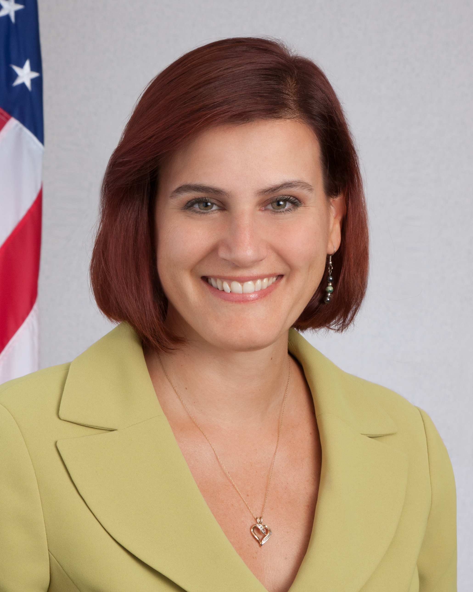

Ms. Connery has also served as Senior Policy Advisor to the Assistant Secretary for Defense Nuclear Nonproliferation at the National Nuclear Security Administration and worked in various other capacities within that organization. She served in Kazakhstan for two years, first as the Department of Energy’s nonproliferation representative for the Embassy and then as the on-site project manager for the shut-down of the BN-350 fast breeder reactor.

Ms. Connery holds a Bachelor’s Degree in International relations from Tufts University and a Master’s of Art in Law and Diplomacy from the Fletcher School.
Ms. Connery has received numerous awards over the course of her career, to include NNSA’s Silver Medal and the Secretary of Energy’s Distinguished Service Award. She was a finalist for the 2012 Service to America Medal for National Security and International Relations. In 2013, she received a Presidential Citation from the American Nuclear Society and in 2015, she was recognized with a Meritorious Achievement Award from the Nuclear Infrastructure Council. She is an active member of the Institute of Nuclear Materials Management and the American Nuclear Society.

